**Experiment 21**

**Lab Book:**

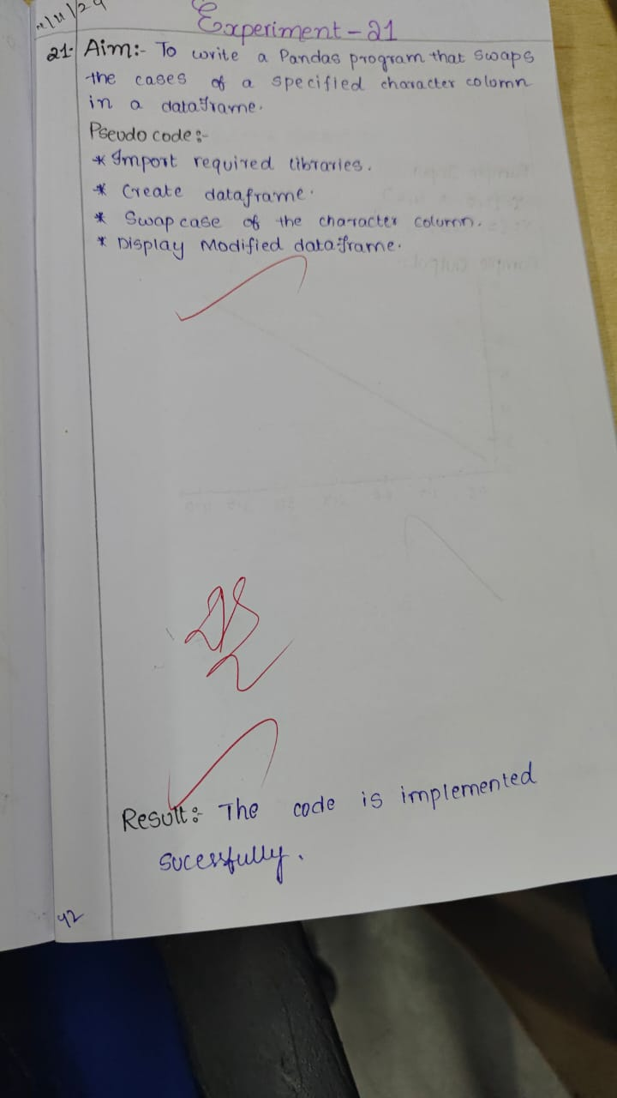

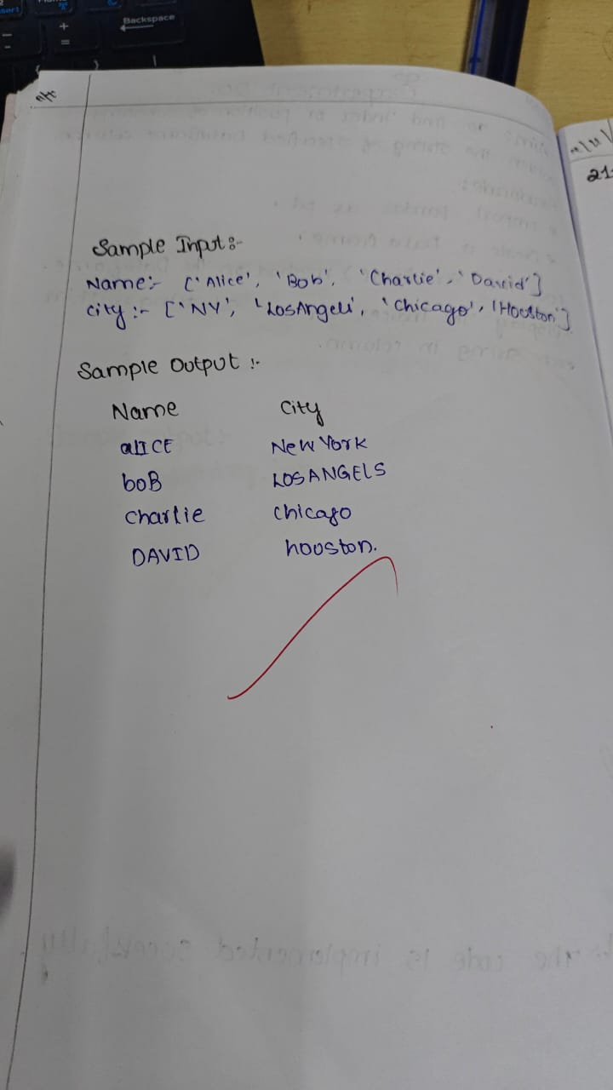

**Code:**

import pandas as pd

data = {

'Name': ['Alice', 'Bob', 'CHARLIE', 'david'],

'City': ['New York', 'LOS ANGELES', 'Chicago', 'houston']

}

df = pd.DataFrame(data)

df['Name'] = df['Name'].str.swapcase()

print(df)

**Sample Output**

